

**Overview of IoT systems architecture, key components, and communication protocols**

**IoT Lab**

**Student Name: Mohamad Osman**

**Submission Date: 13/06/2020**

**Table of Contents:**

**Introduction:** 3

**Architecture of IoT:** 3

**IoT Key Components:** 5

**Communication protocols between hardware equipment in IoT:** 6

**Communication protocols between cloud and end-Nodes:** 8

**References:** 9

**List of Tables:**

**Table 1 types of IoT hardware protocol communication** 7

**Table 2 Communication protocols between cloud and end-Nodes** [7][8] 8

**List of Figures:**

**Figure 1: Architecture of IoT (A: three layers) (B: five layers).** 3

**Figure 2: main IoT layers with some key components** 4

**Figure 3: different technologies for IoT connectivity according to several specs.** 5

# **Introduction:**

Internet of Things is a network of connected devices (Things) interact and recognize each other that empowered by sensors, identifiers, software, intelligence and connectivity and based on several previous technologies such as, information systems, wireless sensors networks, and embedded computing. Internet of things (IoT) in simple words refers to any system of physical devices connected to the internet that receive and transfer data through wireless networks without implicitly human intervention. [1]

# **Architecture of IoT:**

There is no universal consensus on an architecture for IoT systems over the world since, there are different architectures are proposed by different researchers. Some of these architectures are based on three-layers whereas the other are based on five-layers or seven layers. [2]

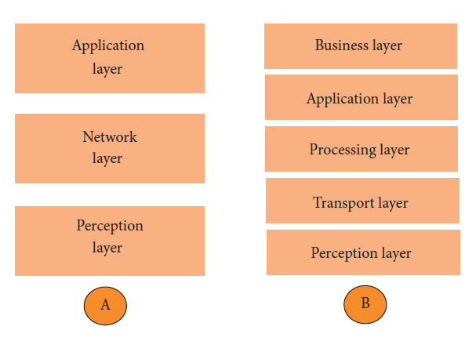

**Figure 1: Architecture of IoT (A: three layers) (B: five layers).**

Figure 1.A shows the early stages of IoT architecture research, this architecture has three layers Application, Network, and Perception.

**The perception layer:** The layer of perception is the physical layer which contains sensors for the purpose of sensing and gathering information about the environment that is surrounding the system. It senses some physical parameters in the environment, or identifies other smart objects. [2]

**The network layer:** This layer is reasonable for connecting to other smart things, network devices, and servers. Its features are also used for transmitting and processing sensor data. [2]

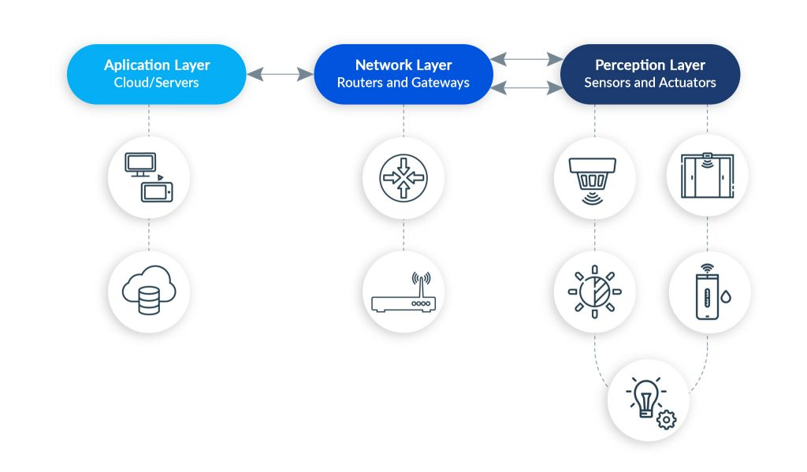**The application layer:** which is responsible for providing the customer with specific client services. It is used to define several applications in terms of IoT technology, for example but not limited, smart houses, smart health, smart transportation, and smart cities. [2]

**Figure 2: main IoT layers with some key components**

The above three layers describes the main idea of IoT, but they are not considered sufficient for the current advanced IoT researches since, researches often focus on finer aspects of the Internet of Things, this why additional layers are proposed for IoT architecture to cover more of technical aspects clearly regarding to this technology.

From this point as shown in Figure 1.B shows the five layers of IoT architecture are perception, transport, processing, application, and business layers. The role of application and perception layers are the same in the new architecture, therefor we highlight the functions of the rest layers which are the transport, processing, and business.

**The transport layer:** this layer is responsible to transfers data from the sensors of the perception layer to the processing layer and vice versa through networks such as wireless, 3G, LAN, Bluetooth, RFID, and NFC [2]

**The processing layer**: is also known as the middleware layer. It stores, analyzes, and processes huge amounts of data that comes from the transport layer. It can manage the lower layers and provide them with a diverse set of services. Which utilizes various technologies, such as databases, cloud computing, and modules for processing big data. [2]

**The business layer:** manages the whole IoT system, including applications, business and profit models, and users’ privacy. [2]

# **IoT Key Components:**

**1- Sensors:** the most significant feature of sensors is their ability to convert the gathered information from the IoT network into data for the purpose of further analysis and processing. [3]

**2- Actuators:** the sensors and actuators are both transducers, which ensures that, they can transform signals from one form to another. Whereas sensors which monitor data generated by devices, actuators are responsible for carrying out actions. These actions may include sound generation, switching on /off a light or locking a door. [3]

**3- Gateways:** An IoT gateway is a device which is used to analyze the basic data. In some cases, when a small number of computing resources are needed for data analysis, IoT gateways serve as decision points and send specific control commands to actuators for the purpose of carrying out actions. Moreover, when advanced data processing is needed or information needs to be processed for further review, gateways move it to a cloud- or on-site server. [3]

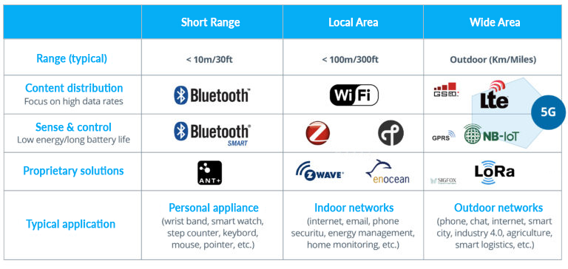**4- Connectivity:** End devices and servers or cloud can be connected via the following technology according to the need of usage as shown in Figure 3, for instance, cellular or satellite networks, Bluetooth, Wi-Fi, Ethernet (Wired LAN), as well as low-power wide-area networks (LPWAN).

**Figure 3: different technologies for IoT connectivity according to several specs.**

**5- Platforms:** An IoT platform is a middleware between hardware-related layers (Perception and Network) on the one hand, and the application layers, on the other.

Currently, there are many corporations provide this service for IoT engineers, such as, Google Cloud, Microsoft Azure, Amazon web services etc... [3]

# **Communication protocols between hardware equipment in IoT:**

Communication between hardware devices as, sensors, actuators and micro-controllers is similar to that between humans, both sides require to speak same language. In electronic devices these languages are called communication protocols. [4]

**Data communication types:**

1- Parallel communication

2- Serial communication: has two types a) Asynchronous, b) Synchronous.

**Parallel communication specs:**

* All the bits of data are transmitted simultaneously on sperate communication lines
* Used for shorter distance
* In order to send (n) bit you need (n) wires or lines so, it is more costly
* Faster than Serial communication, Data can be transmitted in less time

Examples: printers, hard disks

**Serial Communication spec:**

* The data bits are transmitted one by one (bit by bit) on single communication line.
* Long distance transmission
* It requires one communication line instead of n lines for n bits therefor less costly.

Example: Telephone.

**Serial Transfer Parallel Transfer**

**Sender**

**Receiver**

**Sender**

**Receiver**

**Serial communication uses two methods:** [4]

1- Asynchronous:

* Transfer single byte at a time
* No need of clock signal

Example: UART (universal asynchronous receiver transmitter).

2- Synchronous:

* Transfers a block of data (characters) at a time.
* Requires clock signal.

Example: SPI (Serial Peripheral Interface), I2C (Inter Integrated Circuit)

**Protocol:** is a set of rules agreed by both sender and receiver on the following: [4]

* How the data is packed
* How many bits represent a character?
* When the data begins and ends

|  |  |  |  |  |
| --- | --- | --- | --- | --- |
| **Serial Protocol** | **Synchronous/ Asynchronous** | **Type** | **Duplex** | **Data Transfer Rate (kbps)** |
| **UART** | **Asynchronous** | **Peer-to-Peer** | **Full-duplex** | **20** |
| **I2C** | **Synchronous** | **Multi-master** | **Half-duplex** | **3400** |
| **SPI** | **Synchronous** | **Multi-master** | **Full-duplex** | **>1000** |
| **Microwire** | **Synchronous** | **Master/slave** | **Full-duplex** | **> 625** |
| **Wire** | **Asynchronous** | **Master/slave** | **Half-duplex** | **16** |

**Table 1 types of IoT hardware protocol communication [4]**

**UART:** universal asynchronous receiver/transmitter (UART) is a microchip that performs serial-to-parallel conversion of data received from peripheral devices and parallel-to-serial conversion of data coming from the CPU for transmission to peripheral devices. [5]

**I2C:** An inter-integrated circuit (Inter-IC or I2C) is a multi-master serial bus that connects low-speed peripherals to a motherboard, mobile phone, embedded system or other electronic devices. Also known as a two-wire interface. [6]

**SPI:** Synchronous serial interface (commonly abbreviated as SPI): In SPI, the receiver does not have any internal clock, which indicates that the receiver is unable to individually synchronize its data line reading with the transmission rate of the transmitter. The receiver requires some assistance and that support is available in the form of a clock signal, which is shared by the receiver and transmitter. The clock signal serves as a control line that informs the receiver about the best time to read from the data line. This implies that the receiver and transmitter should synchronize their accessibility to the data line to successfully send data. [7]

# **Communication protocols between cloud and end-Nodes:**

|  |  |  |  |  |
| --- | --- | --- | --- | --- |
| **Protocol**  **Name** | **Standard** | **Frequency** | **Range** | **Data Rate (kbps)** |
| **Wi-Fi** | **802.11n** | **2.4- 5 GHz** | **50m** | **1 Gbps (Max)** |
| **Bluetooth** | **802.15.n** | **2.4 GHz** | **50-150 m** | **1 Mbps** |
| **LoRa WAN** | **LoRaWAN** | **Various** | **2-5 km** | **0.3-50 kbps** |
| **ZigBee** | **802.15.4** | **2.4 GHz** | **Half-duplex** | **16** |
| **Z-Wave** | **ZAD12837/ITU-T G.9959** | **900 MHz** | **30 m** | **9.6 / 40 / 100 kbps** |
| **Cellular** | **2G, 3G, 4G(LTE), 5G** | **900 /1800 /1900 / 2100 MHz** | **Various** | **1 Gbps (Max)**  **For 5G tech** |
| **NFC** | **ISO/IEC 18000-3** | **13.56 MHz** | **10 cm** | **100-420 kbps** |
| **Sigfox** | **Sigfox** | **900 MHz** | **30-50 km** | **10-1000 bps** |
| **Neul** | **Neul** | **900, 458 MHz, 470-790 MHz** | **10 km** | **100 kbps** |
| **Low PAN** | **RFC6282** | **Various** | **NA** | **NA** |

**Table 2 Communication protocols between cloud and end-Nodes** [8]

# **References:**

|  |  |
| --- | --- |
| [1] | M. A. J. Jamali, B. Bahrami, A. Heidari, P. Allahverdizadeh and F. Norouzi, Towards the Internet of Things., Cham, Switzerland: Spring, 2020. |
| [2] | P. Sethi and S. R. Sarangi, "Internet of Things: Architectures, Protocols, and Applications," *Journal of Electrical and Computer Engineering ,* vol. Volume 2017 , no. Article ID 9324035, p. 25, 2017. |
| [3] | A. Kalyan, "IoT Key Components – From Device to Application," BEYONDROOT Technology Services, [Online]. Available: https://beyondroot.com/blog/iot-key-components-from-device-to-application/. [Accessed 12 June 2020]. |
| [4] | "Embedded Communications Protocols and Internet of Things," G Pullaiah College of Engineering and Technology, [Online]. Available: shorturl.at/ciuW8. [Accessed 10 June 2020]. |
| [5] | "Universal Asynchronous Receiver/Transmitter (UART)," techopedia, [Online]. Available: https://www.techopedia.com/definition/3669/universal-asynchronous-receivertransmitter-uart. [Accessed 10 June 2020]. |
| [6] | " Inter-IC (I2C)," techopedia , [Online]. Available: https://www.techopedia.com/definition/319/inter-ic-i2c. [Accessed 10 June 2020]. |
| [7] | "Serial Interface," techopedia, [Online]. Available: https://www.techopedia.com/definition/9312/serial-interface. [Accessed 10 June 2020]. |
| [8] | K. Talkie, "Top 10 IoT Protocols You Need to Know," Youtube, 29 October 2016. [Online]. Available: https://www.youtube.com/watch?v=jYrkujWlbt0. [Accessed 12 June 2020]. |
| [9] | "Software, Platform, Infrastructure Model (SPI Model)," techopedia, [Online]. Available: https://www.techopedia.com/definition/14019/software-platform-infrastructure-model-spi-model. [Accessed 10 June 2020]. |
| [10] | M. Hasan, "Top 15 Standard IoT Protocols That You Must Know About," ubuntupit, [Online]. Available: https://www.ubuntupit.com/top-15-standard-iot-protocols-that-you-must-know-about/. [Accessed 12 June 2020]. |